General Data Protection Regulation
GDPR is a European Regulation put into UK law by the Data Protection Act 2018 and it did not change
after Brexit.
Despite some IT support companies offering “GDPR compliant” solutions, creating a comprehensive
Data Protection Project involves far more than just IT compliance. This can be easily demonstrated by
understanding the 7 principles of the GDPR that are required of any business when processing data.
◼ Lawfulness, Fairness & Transparency Policy Requirements.
◼ Purpose Limitation Principle: (processing data only for the identified & explicit original purpose)
◼ Data Minimisation Principle: data must be relevant & limited to what is necessary (this includes
avoiding duplication where possible).
◼ Data Storage to be accurate and, where possible, kept up to date.
◼ Storage Limitation Principle: personal data is only kept for a period consistent with the purpose it
was collected for.
◼ Integrity & Confidentiality Principle: data is processed in a manner that ensures appropriate
security of the personal data.
◼ Accountability Principle: it is the responsibility of the controller for complying with the principles,
and to have appropriate processes and records in place to demonstrate that they have complied.

Video 1 - Transcript.pdf
86.2 KB

Glossary
TERM | DEFINITION
Personal Data | Data that can be used to identify a living individual (different from the US term PII).
Controller | The party (organisation) that decides how the data is managed (this is a company not an individual).
Processor | The party that processes personal data on behalf of the controller (i.e. service provider).
Breach | A breach of security leading to the accidental or unlawful destruction, loss, alteration, unauthorised disclosure of, or access to, personal data.
Special Category Data | Types of data identified as being sensitive such as race or ethnic origin, religious or philosophical beliefs, etc.
Organisational Measures | These commonly refer to (staff) training, policies, procedures, documentation and monitoring of all aspects to ensure alignment to compliance.
Technical Measures | This audit will include an assessment of the legal basis for processing, location of data, categories of data, retention schedules and staff and processor access (amongst much more).

Article 5 (1) (F)
Processed in a manner that ensures appropriate security of the personal data, including protection against unauthorised or unlawful processing and against accidental loss, destruction or damage, using appropriate technical or organisational measures.
GDPR Text (Article 5 (1) (F))
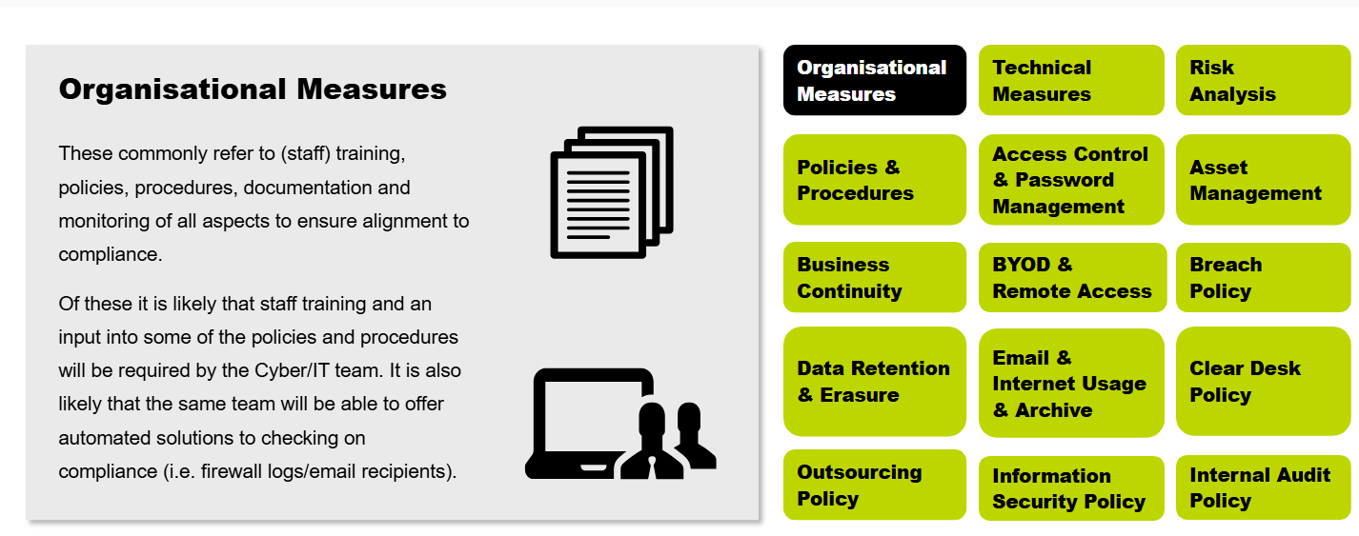
Measure | Simple Explanation
Risk Analysis | Identifying what could go wrong, how likely it is, and what impact it could have on the business or personal data.
Policies & Procedures | Written rules and instructions explaining how staff should handle information and perform tasks securely.
Access Control & Password Management | Ensuring only authorised people can access systems and requiring strong passwords and account security.
Asset Management | Keeping an inventory of company devices, software, databases, and information assets so they can be protected.
Business Continuity | Plans that help the business continue operating during disruptions such as cyberattacks, power failures, or disasters.
BYOD & Remote Access | Rules for employees using personal devices (Bring Your Own Device) and securely accessing company systems from outside the office.
Breach Policy | Procedures for responding to a data breach, including reporting, investigation, and notifying affected parties.
Data Retention & Erasure | Defining how long data should be kept and ensuring it is securely deleted when no longer needed.
Email & Internet Usage & Archive | Rules for using email and the internet safely and storing important communications for compliance purposes.
Clear Desk Policy | Requiring employees to keep desks free of sensitive documents when unattended to prevent unauthorised viewing.
Outsourcing Policy | Ensuring third-party suppliers and service providers protect company data and comply with legal requirements.
Information Security Policy | The main document outlining the organisation's approach to protecting information and cybersecurity.
Internal Audit Policy | Regularly checking whether policies, controls, and security measures are working correctly and being followed.

This paragraph is explaining that GDPR applies to all organisations, not just large companies, and that data breaches are very common.
Simple Breakdown
“Whilst press coverage of ICO action is very limited...”
This means:
- The news does not report every GDPR case.
- Many companies receive penalties or investigations without becoming widely known.

“The ICO have taken action against many Enterprise and SME sized businesses...”
- ICO = Information Commissioner's Office (the UK's data protection regulator).
- Enterprise businesses = large companies.
- SMEs = Small and Medium-sized Enterprises (smaller businesses).
Meaning:
➡️ Both large and small organisations can be investigated or fined for GDPR violations.

“Doorstep Dispensaree Ltd and ICO action - £275,000 fine”
This is an example showing that:
- A company suffered a data breach.
- The ICO investigated it.
- The company received a large financial penalty.
The example is used to demonstrate that GDPR enforcement is real and can be expensive.

“The ICO are obligated to investigate any breach...”
This means:
- When a serious personal data breach is reported, the ICO has a legal duty to investigate.
- They examine:
  - What happened.
  - What data was affected.
  - Whether the company had proper security measures.
  - Whether GDPR rules were followed.

“ALL companies will suffer a breach regardless of severity.”
This means:
- No organisation is completely immune from mistakes, cyberattacks, lost devices, phishing emails, or human error.
- Some breaches are small.
- Some breaches are serious.
Examples:
Minor Breach | Major Breach
Sending an email to the wrong person | Customer database stolen by hackers
Losing a USB stick | Ransomware attack
Employee accessing data accidentally | Large-scale personal data leak
The point is:
➡️ Breaches are almost inevitable.
➡️ What matters is how well the organisation prepares for, detects, and responds to them.

Easy Seminar/Exam Explanation
"The statement highlights that GDPR compliance is important for organisations of all sizes. The ICO can investigate data breaches and impose penalties when organisations fail to protect personal data. Since data breaches can occur in any organisation, businesses must implement appropriate technical and organisational security measures to reduce risk and respond effectively when incidents occur."
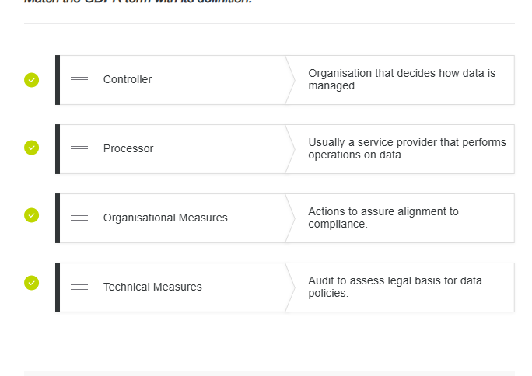
Lesson 4 of 10

ISO 27000
One of the core deliverables of the ISM role is the production of an Information Security Management System (ISMS). One of the major resources used is the ISO 27000 family of guides and standards. The complete family of guides and standards are shown in figure 7, the most relevant ones are discussed here.

Family of ISO Guides.

ISO 27001 is a specification for an ISMS – however like many other standards and specifications the complete guide should be reviewed, and only pertinent sections should be selected and implemented. For example, if your company doesn’t do any software development then those sections of the standard obviously won't apply.
The ISMS will include sections that define the management approach to, and integration of security as it relates to people, processes and technology.
In addition an ISMS is not an island – it needs to align and integrate with other parts of the quality management system such as ITIL, COBIT and TOGAF.
One of the major drivers for following a standard specification such as ISO 27001 is that the business can be audited against this standard – which can be used to demonstrate to clients and partners that certain security standards and processes have been implemented.

ISO 27002
Click to flip
ISO 27002 is one of a number of guideline standards or 'codes of practice' which go into more detail and provide guidelines around each part of the standard. As discussed above, not all these guidelines will be applicable for every business.
Click to flip
ISO 27005

&

ISO 31000
As mentioned previously ISO 27005 and ISO 31000 are also key standards, and as discussed previously there is even a document produced by the Open Group that maps the FAIR standard to ISO 27005.

FAIR helps organizations measure risk in financial terms, so they can make smarter decisions about where to invest in security.
This sentence means that there are several recognised frameworks for managing risk:
- ISO 31000 → A general standard for risk management in any organisation.
- ISO 27005 → A standard specifically for information security risk management.
- FAIR (Factor Analysis of Information Risk) → A framework that helps organisations measure and quantify cyber risks in financial terms.
The sentence also says that:

PCI-DSS
The Payment Card Industry – Data Security Standard (PCI-DSS) is a standard that was created by the payment card industry security standards council (PCI-SSC) to bring together the policies and best practices of the main card providers – that is Mastercard, Visa, Amex, Discover and JCB. The standard consists of 12 objectives in 6 categories which are:
Discover and JCB. The standard consists of 12 objectives in 6 categories which are:
Build and maintain a secure Network and systems; Objective1: install and configure a firewall to protect cardholder data. Objective 2: Not using vendor-supplied defaults for system passwords and other security parameters.
Protect Cardholder Data: Object3: protecting stored cardholder data Object 4: Encrypting transmission of cardholder data across open, public networks.
Maintain a vulnerability Management Programs: Objective 5: Protecting all systems against malware, and regularly updating anti-virus software or programs. Objective 6: Developing and maintaining secure systems and applications.
Implement Strong Access control Measures: Objective 7: Restricting access to cardholder data by business (on a) need to know (basis). Objective 8: Identifying and authenticating access to system components. Objective 9: Restricting physical access to cardholder data.
Regular monitoring and test networks: Objective 10: Tracking and monitoring all access to network resources and cardholder data. Objective 11: Regularly testing security systems and processes.
Maintain an Information Security Policy: Objective 12: Maintaining a policy that addresses information security for all personnel.

In addition, the diagram shown below demonstrates where the above measures should be implemented, and how they are supplemented by actions and best practices by the card providers as well.

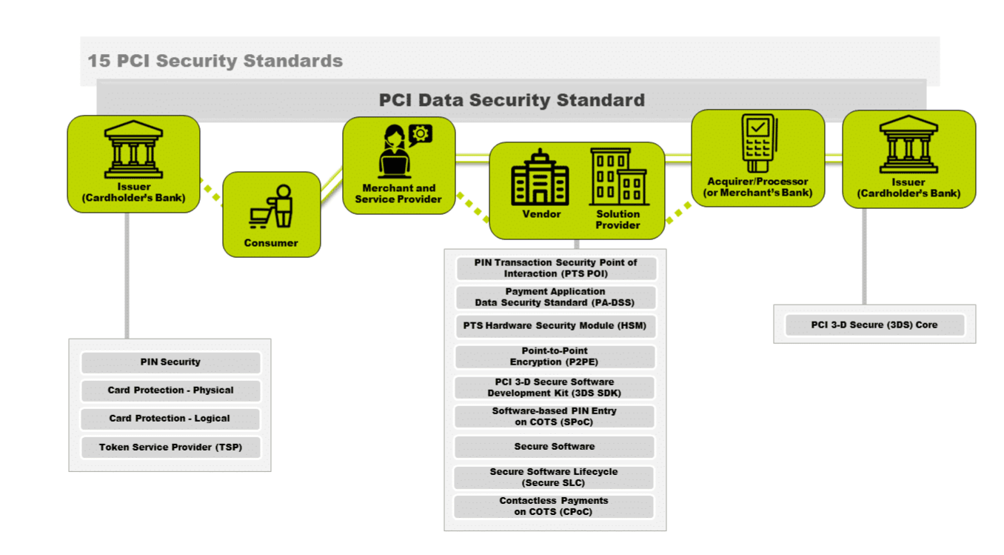

NIST

The current FIPS publications can be found at FIPS (2018). NIST (National Institute of Standards and Technology) – Simple Explanation
What is NIST?
- NIST is a U.S. government agency that develops standards, guidelines, and best practices.
- Founded in 1901 as the National Bureau of Standards.
- Renamed NIST in 1988.
- Its goal is to improve technology, innovation, security, and quality of life.

Why is NIST important in Cybersecurity?
NIST provides:
- Security Publications (SP 800 Series) – detailed cybersecurity guidance.
- Cybersecurity Framework (CSF) – a framework for managing cyber risks.
- FIPS Standards – security standards used by U.S. government systems.

NIST Cybersecurity Framework (CSF)
The framework helps organizations manage cybersecurity risks through five core functions:
Function | Meaning
Identify | Know your assets, systems, data, and risks.
Protect | Put safeguards in place (passwords, MFA, training, firewalls).
Detect | Discover attacks or security incidents quickly.
Respond | Take action when an incident occurs.
Recover | Restore systems and normal operations after an incident.

Easy way to remember:
I-P-D-R-R
Identify → Protect → Detect → Respond → Recover
Example:
- Identify: List company laptops and data.
- Protect: Use MFA and antivirus.
- Detect: Monitor logs and alerts.
- Respond: Isolate infected device.
- Recover: Restore from backup.

FIPS (Federal Information Processing Standards)
What is FIPS?
- A set of security standards created and managed by NIST.
- Mainly used by U.S. federal government agencies.
- Designed to protect government information systems.

Important Point:
- FIPS is not only for government agencies.
- Private companies can also adopt FIPS standards to improve security.

Example:
- FIPS 140-3 is used to certify cryptographic modules (encryption products).

Quick Exam / Seminar Notes

NIST
- U.S. standards organization.
- Founded 1901.
- Renamed NIST in 1988.
- Produces cybersecurity standards and guidance.

NIST CSF
Five functions:
- Identify
- Protect
- Detect
- Respond
- Recover

Benefits of NIST CSF
- Improves cybersecurity management.
- Helps identify and reduce risks.
- Widely used worldwide.
- Flexible for organizations of any size.

FIPS
- Federal Information Processing Standards.
- Developed by NIST.
- Used mainly by U.S. government agencies.
- Can also be adopted by private organizations.
- Example: FIPS 140-3 (encryption certification).

One-Line Revision
NIST provides cybersecurity guidance and standards; the NIST Cybersecurity Framework helps organizations Identify, Protect, Detect, Respond to, and Recover from cyber threats, while FIPS provides security standards mainly for U.S. government systems.

COBIT
what does this mean in COBIT: Separating Governance from Management.

COBIT: "Separating Governance from Management" – Simple Explanation
One of the key ideas in COBIT is that Governance and Management are different activities and should be treated separately.

Governance = Direction and Oversight
Governance is usually performed by senior executives, directors, or the board.
Their job is to:
- Set objectives and strategy.
- Decide what should be achieved.
- Monitor performance.
- Ensure risks are managed.
- Make sure the organization gets value from IT.
Example:
The board decides:
"We want to improve cybersecurity and comply with GDPR."

Management = Planning and Doing
Management is usually performed by IT managers and operational teams.
Their job is to:
- Plan how to achieve the objectives.
- Build and operate systems.
- Manage staff and resources.
- Monitor daily activities.
Example:
The IT manager decides:
"We will implement MFA, conduct staff training, and deploy security monitoring tools.
Imagine a company wants to improve cybersecurity:

COBIT asks:
- Are we investing in the right security controls?
- Do they support business goals?
- Are risks being managed properly?
- Are we compliant?
➡️ Strategic and management-level view

ITIL asks:
- How should the IT team handle security incidents?
- What steps should be followed for system changes?
- How do we restore services quickly?
➡️ Operational and day-to-day view

Easy Revision Notes
COBIT
- Governance framework.
- Top-down approach.
- Strategic focus.
- Aligns IT with business.
- Uses audits and maturity assessments.
- Answers: "Are we doing the right things?"
ITIL
- IT Service Management framework.
- Bottom-up approach.
- Practical focus.
- Provides operational processes.
- Uses KPIs and service metrics.
- Answers: "Are we doing things right?"

One-Line Exam Answer
COBIT focuses on IT governance and strategic alignment with business goals, while ITIL focuses on managing and improving day-to-day IT services and operations.
Lesson 7 of 10

COBIT vs. ITIL

An Introduction to COBIT
The Control Objectives for IT (COBIT) is another American based, international standard that deals with the governance, assurance and auditing of business information systems with an emphasis on risk management, information security and compliance. It is often used as part of the assurance process of the Capability Maturity Model (CMM).

THE COBIT PRINCIPLES
- 1
1
Meeting Stakeholder Needs.
- 2
2
Covering the Entire Enterprise.
- 3
3
Application of a Single Integrated Framework.
- 4
4
Taking a Holistic Approach.
- 5
5
Separating Governance from Management.

An Introduction to ITIL
The Information Technology Infrastructure Library (ITIL) is mostly concerned with service design, implementation and operations and certainly since v3 security has been an intrinsic part of that.

THE ITIL PRINCIPLES
- 1
1
Continual Service Improvement.
- 2
2
Service Design.
- 3
3
Service Organisation.
- 4
4
Service Transition.
- 5
5
Service Strategy.
Indeed if you use ISO 27001 to create your ISMS then the ITIL integration is built into that process.
In many ways COBIT and ITIL provide alternative ways of looking at the same problem, and table 1 compares the two approaches.
Feature | COBIT | ITIL
Approach | Top Down (emphasising management and stakeholder requirements) | Bottom Up (looking at how to determine and measure incidents and events)
Focus | Strategic (establishing the business-IT relationship) | Practical (providing a set of processes and procedures that IT staff can follow)
Monitoring | Benchmarks (auditing process, against the CMM if required) | Key Performance Indicators (can be monitored regularly and give a day by day view if required)
Quality | Assurance (providing feedback as part of an audit or governance process) | Control (providing processes and procedures that can be audited, and once approved these provide management processes that are followed as part of daily operations; for example change and incident management)

ITIL v3 DIagram (Kempter, 2019)

- Service Strategy – Define IT services based on business goals and customer needs.
- Service Design – Design reliable, secure IT services and processes.
- Service Transition – Manage changes and deploy new or updated services safely.
- Service Operation – Handle day-to-day IT operations and support (like incident and problem management).
- Continual Service Improvement – Keep improving services to meet evolving needs.
Great question! The five stages I mentioned are from ITIL v3.
ITIL v4 is the newer version and has key differences:
- Instead of a linear lifecycle, it uses a Service Value System (SVS) focused on delivering value.
- It replaces the 26 processes of v3 with 34 flexible "practices" that can be used across different stages.
- It integrates modern ways of working like Agile, DevOps, and automation.
- It emphasizes outcomes, customer experience, and business value over rigid processes.
So while v3 is more structured and process-heavy, v4 is more adaptable and holistic—designed for today’s fast-moving tech environments. 🚀
Copy
Good response
Bad response
